My impact community

Task 1: Fill in and move the text boxes into each of the concentric circles on the next page, identify individuals, groups or organisations you interact with to generate impact in each of the three concentric circles on the next page:
- Within your institution
- Within your disciplinary networks
- Non-academic partners, stakeholders, publics

Note:
- Have you missed out any hard to reach groups? (significant impact but limited interest or influence)?
- If you have a REF impact case study, use the highlighter tool to highlight those who are benefiting from your case study
- If you’re not engaging much yet, add people, groups or organisations you would like to interact with

Task 2: Reflect on the community you mapped in task 1 and use the following questions to identify actions to build your impact community (write these on your Action Sheet):
- What could you do to strengthen your social capital with those you have identified?
- If you identified individuals, groups or organisations you would like to engage with, what are their interests or needs, and how might you be able to reach out to them empathically to help them where they are at?
- If you highlighted REF beneficiaries in task 1, who is doing what to benefit groups outside your REF impact?
- What more could you do?
- Revisit community questions you didn’t answer on p1-2 handout

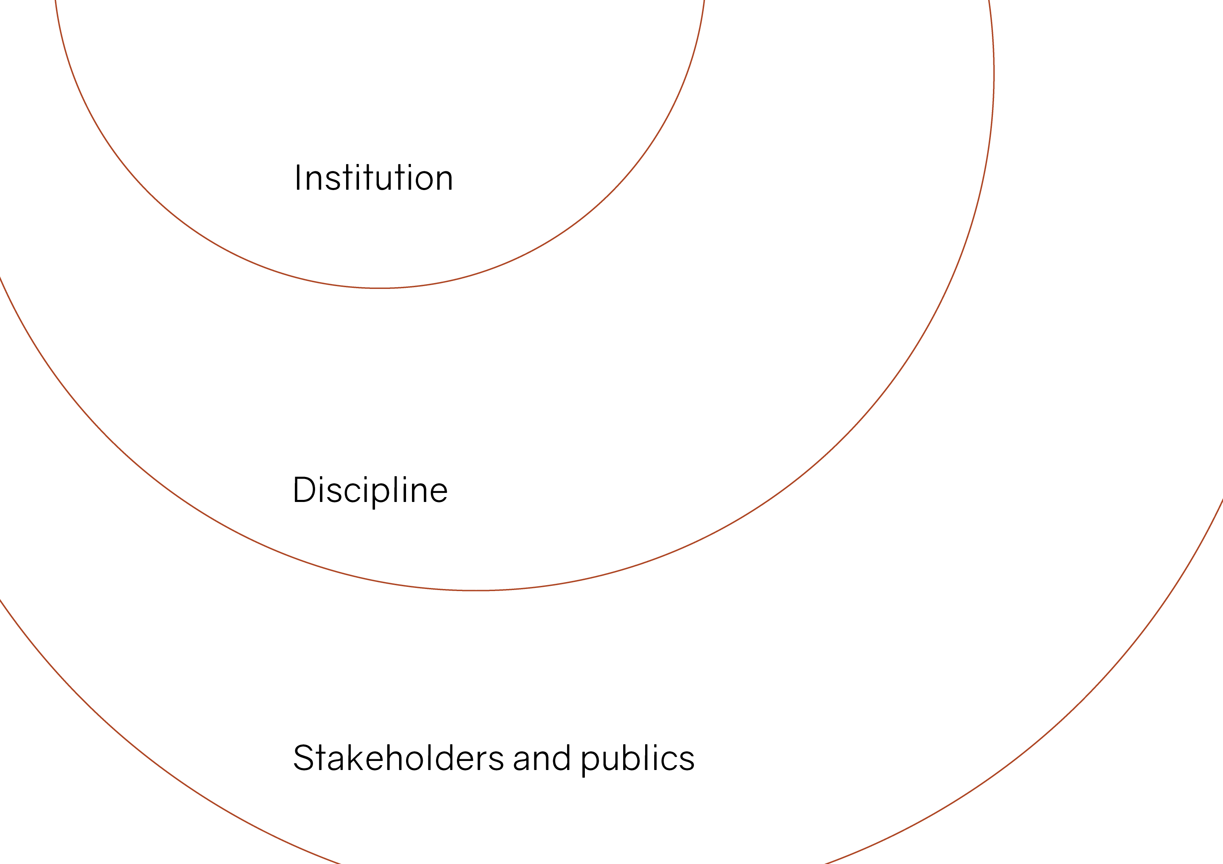
Enter a person, group or organisation here…
Enter a person, group or organisation here…
Enter a person, group or organisation here…
Enter a person, group or organisation here…
Enter a person, group or organisation here…
Enter a person, group or organisation here…

Enter a person, group or organisation here…
Enter a person, group or organisation here…

