Fast Track Impact Planning Template

Impact goal | Target stakeholders or publics | Reasons for being interested in the project | Activities to engage this target group | Indicators of successful engagement [and means of measurement] | Indicators of progress towards impact [means of measurement] | Risks to activities [and mitigation] | Risks to impact [and mitigation] | Who is responsible and what resources are needed? | Timing

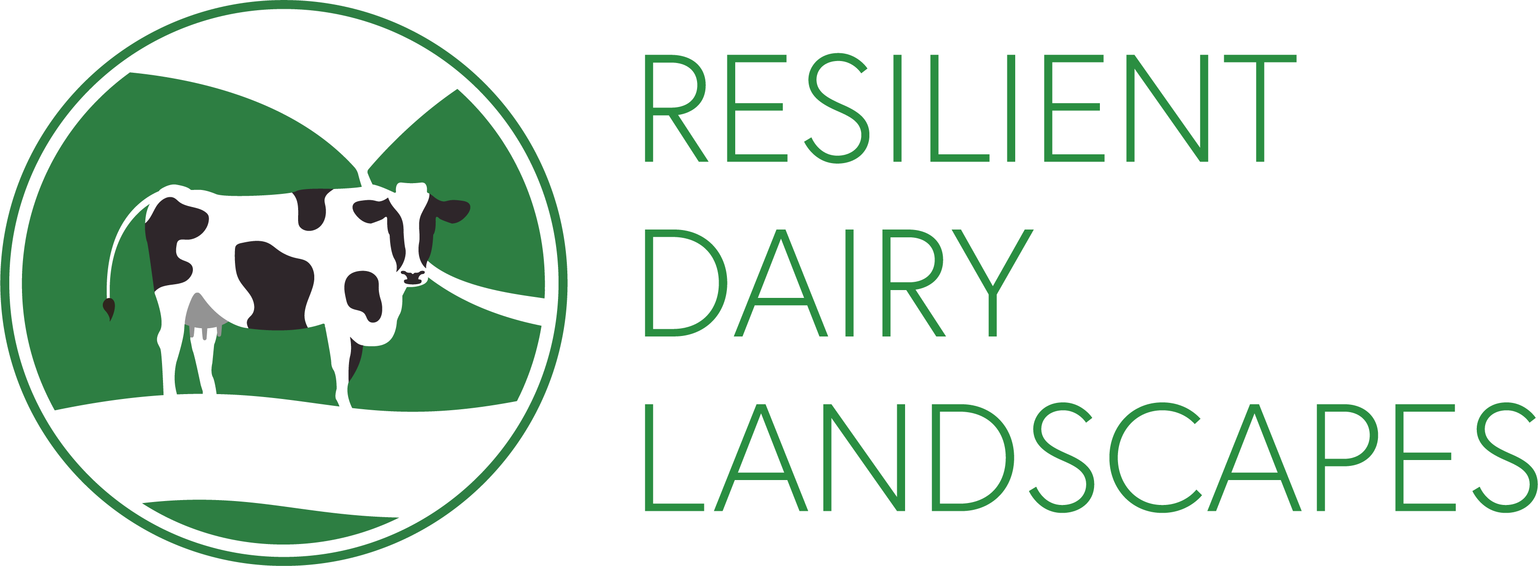
Worked example
Overall impact goal: to develop and use a food system model to evaluate and then propose a range of dairy farming interventions that can increase the resilience and sustainability of production in the face of difficult to predict interactions between environmental, social and market forces.
Impact goals | Target stakeholders or publics | Reasons for being interested in the project | Activities to engage this target group | Indicators of successful engagement [and means of measurement] | Indicators of progress towards impact [means of measurement] | Risks to activities [and mitigation] | Risks to impact [and mitigation] | Who is responsible and what resources are needed? | Timing
Work with dairy farmers, the dairy industry and Government to develop scalable new pricing models based on Payments for Ecosystem Services (PES), inform the development of food, farming and environmental policy relating to PES, natural capital and adapting to environmental change, and support Government's role in providing early warning of major, notifiable or new and emerging animal diseases in the diary sector, in the context of the emerging post-Brexit agricultural policy regime in England and Scotland. | Dairy industry stakeholders (as above)  National government departments and agencies, local councils  Ecosystem service beneficiaries including publics, Cumbrian utilities companies, Network Rail, supermarkets, Cumbrian food and drink manufacturers, insurers, local businesses  Intermediaries and networks including North Pennines AONB, Local Nature Partnership, Catchment Pioneer  Third sector organisations including Rivers Trusts, Game & Wildlife Conservation Trust, Innovation in Agriculture, BITC  N8 AgriFood, 3Keel, CISL | Increased profitability and resilience to Brexit  Meet objectives of 2011 NEWP, PES Action Plan and PES aspirations in 25 year plan  Opportunities to invest in natural capital to increase resilience to flood threats, climate change and demonstrate CSR  Opportunities to leverage additional funding to meet operational objectives  Intersections with a range of strategic objectives and initiatives in these organisations  Achieving impact from research | Promote milk premium and related schemes to new entrants | Materials co-developed with Nestle/First Milk via their network [material available online] | Significant numbers of new scheme entrants [Nestle scheme records] | No new materials developed [3Keel to lead development] | No new scheme entrants [Nestle and First Milk to lead] | Nestle, First Milk, 3Keel | Late 2018
 |  |  | Seminars in Westminster (with Natural England) and Edinburgh, policy brief with NE and GFS projects | Attendance by identified priority teams, follow-up opportunities taken up relevant teams [event records] | Integration of findings to post-Brexit agriculture policy [citations and testimonials] | Poor attendance [work with NE to target Defra teams, advisory board members for Scottish Government] | No Brexit or no policy influence [work with N8 AgriFood and GFS high level network] | Mark with N8 and GFS programme secretariat | November 2018 (London), 2019 (Scotland) then ongoing
 |  |  | Investment brochure, website and PES registry promoted via stalls and presentations at key regional events | Brochure, website and registry launched, presentations delivered [Google analytics, event records] | Initial investment from new companies with interest in Cumbrian landscape [registry entries] | Major private investment from at least one new company or a number of smaller investments [registry entry] | No new investment [work with Government and Nestle to create conditions necessary] | Mark with Nestle, BITC, 3Keel, Wildlife Trusts and IUCN | 2021
 |  |  | Co-development of activities above for beneficiaries | Evidence of intermediary buy-in to launched resources [attendance at presentations, newsletter list] | Additional funding for intermediary activities linked to PES funding [annual reports, testimonials] | Limited buy-in [3Keel and BITC to lead via their networks] | As above | As above | 2021
 |  |  | Input to relevant expert groups, consultations, select committees and boards, for example Defra’s Social Science Expert Group and Scottish Government's Strategic Research (RESAS) Programme Board | Written and/or oral evidence provided as opportunities arise [citations in relevant documents] | Integration of findings to post-Brexit agriculture policy [citations and testimonials] | Few relevant opportunities or insufficient time to engage with them [training and support for PDRAs to lead drafting of responses] | No Brexit or no policy influence [work with N8 AgriFood and GFS high level network] | Mark with relevant Co-Is | Ongoing
 |  |  | Engage with the Parliamentary Office of Science and Technology on POSTnote or policy brief on “Post-Brexit Resilience and Sustainability of UK Dairy Sector” | Production of POSTnote or policy brief [new materials online including project findings] | Integration of findings to post-Brexit agriculture policy [citations and testimonials] | Lack of interest from POST [launch GFS branded policy brief at seminars in London and Edinburgh] | No Brexit or no policy influence [work with N8 AgriFood and GFS high level network] | Mark with relevant Co-Is | 2020-21
Engage with innovators and influencers from business, government and the third sector to support the transformation of ecosystem management within the dairy supply chain, in Cumbria, and across different commodities at a national and international scale. | Dairy industry, farmers, third sector and government.  Wheat farmers and supply chain  Nestle’s international network  UNCCD, UNFAO, UNEP, CGIAR | Dairy, wheat and other agricultural sectors are interested in improved resilience and profitability in the face of uncertainties from climate change, Brexit and other drivers of change  Mainstreaming insights from this research across the company that increase resilience, sustainability and profitability  Mainstreaming PES as an approach to increasing funding for environmental management and so improving the resilience and sustainability of agricultural systems around the world. Contribution to strategic objectives around PES, Sustainable Land Management, climate change adaptation and other priorities in the international land sector | Set up a website and Twitter account as part of a targeted social media strategy | Website and Twitter feed launched and growing [target 200 followers by year 2, >1000 by end of project] | Expressions of interest, collaboration and application of findings from international contacts [engagement and impact captured in Evernote impact tracking system] | Limited online engagement [training for Jenny and support from Mark Reed who has >60,000 followers across his accounts] | Limited online reach reduces likelihood of opportunities arising or opportunities are missed [training for Jenny who will pass all opportunities to Mark to follow up] | Jenny with support from Mark | Website and Twitter launched March 2018, ongoing work
 |  |  | Produce two short films targeting dairy stakeholders and the policy community: i) evidence-based scenario films depicting different dairy sector futures; ii) project overview film with recommendations to enhance the resilience and sustainability of UK and international dairy systems | Films used to support Social Innovation Labs, qualitative interviews and events with stakeholders [integration of films into successful events] | See indicators for SILs and policy engagement | See risks for SILs and policy engagement activities | See risks for SILs and policy engagement activities | Jenny and Mark with BITC and 3Keel | Early 2019
 |  |  | Produce shorter edited versions of the films above for promotion to publics and other audiences via social media | Strong engagement with films online [>100 views in first quarter, rising to >1000 by end project] | Expressions of interest, collaboration and application of findings from international contacts [engagement and impact captured in Evernote impact tracking system] | Limited online engagement [training for Jenny and support from Mark Reed who has >60,000 followers across his accounts] | Limited online reach reduces likelihood of opportunities arising or opportunities are missed [training for Jenny who will pass all opportunities to Mark to follow up] | Jenny with support from Mark | 2019
 |  |  | Present research findings at stakeholder events/conferences | Presentations at one or more event per year in last three years of project [slides] | As above | Limited engagement at or after events [careful selection of events in collaboration with non-academic partners] | Poor engagement limits opportunities or opportunities are missed [target more relevant events based on lessons learned] | All Co-Is | 2019-21
 |  |  | Work closely with the Sustainable Intensification Platform, Centre for the Evaluation of Complexity Across Nexus & GFS projects in joint events/ briefings | Engagement in at least one joint event with CECAN and other GFS projects [event records] | As above | As above | As above | Jenny and Mark | Ongoing
 |  |  | Second BITC-led “Seeing is Believing” visits on behalf of Prince of Wales: for business with international supply chains | Events well attended by relevant people [event records] | Awareness & new practices [“postcard to your future self” and online survey after event, with follow-up after 6 months] | Weak attendance [BITC has strong reputation and network, and has track record of strong attendance] | Ideas not adopted [understand why from survey responses and adapt to feedback] | Jenny and Mark, SurveyMonkey account | 2021

